**Welcome to Together for Music**

**What is Together for Music?**

**Together for Music** is a **festival of music, workshops, performances and activities** at Symphony Hall.

**When is it happening?**

Together for Music will take place at:

Symphony Hall, Broad Street, Birmingham B1 2EA

on Friday 14th March between 9AM - 3PM.

**Who will I see on the day?**

You will be greeted at our welcome desk by members of staff from Music for Youth and B:Music. They will show you where to go.

You will see our stewards around the venue. Our stewards will be wearing B:Music Polo Shirts.

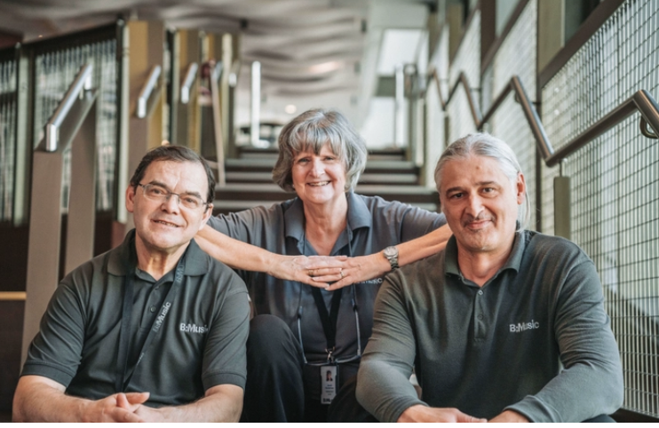

You will also see other young people from schools who are watching and performing.

The venue is open to the public, so you will also see lots of other people enjoying their day.

We have a café called B:Eats at our venue, so you will also see people enjoying some food.

**Where to come in?**

You come in through the main entrance off Centenary Square

The front of Symphony Hall looks like this: 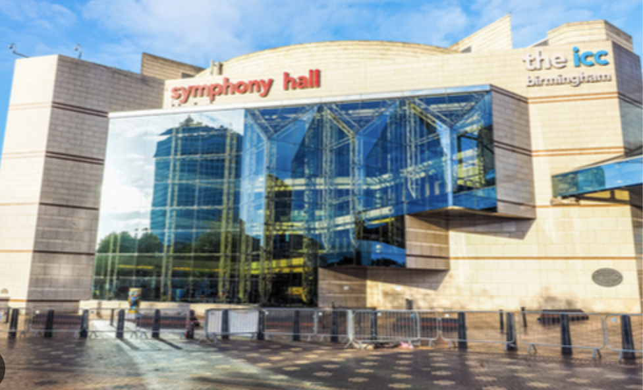

The welcome desk will be directly in front of you as you enter the building.

**How can I get there?**

Symphony Hall’s address is:

**Symphony Hall, Centenary Square, Birmingham B1 2EA**

**Travelling by Coach or Minibus**

There is a place for mini buses coaches to drop off in Cambridge Street.

**Travelling by Bus**

We are easily accessible by bus. There are lots of bus stops nearby.

**Travelling by Tram**

The Library tram stop is just by the Symphony Hall front entrance on Centenary Square. Plan your journey with [West Midlands Metro.](https://westmidlandsmetro.com/journey-planner/)

**Travelling by Train**

Birmingham New Street and Snow Hill stations are near to Symphony Hall.

Train times can be checked at the [National Rail website](https://www.nationalrail.co.uk/).

**Parking**

Parking facilities for Symphony Hall include Q-Park Brindleyplace and Q-Park Mailbox

**What will I experience at Together for Music?**

There will be lots of things to see and do at Together for Music.

There will be **musical performances, including choirs, orchestras, singers and soloists, stalls to visit and music workshops.**

There will be lots of people and sometimes it might be a little bit loud.

There will be quiet rooms that you can use if things get too noisy. Our stewards or staff at the Welcome Desk can help you find these.



**Where is it taking place?**

Together for Music will take place at **Symphony Hall**.

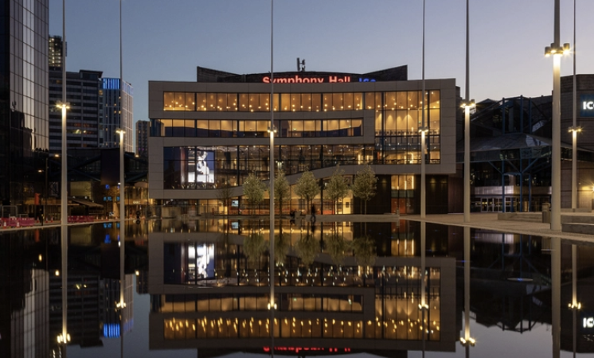

There will be six areas where things are happening for Together for Music.

These are:

1. **Ground Floor – in Symphony Hall this is called Level 3 (there are more floors below ground level) or the Stalls Level**

This is where our welcome desk will be.

1. **Foyer – this is on Level 4**

There will be tables with people and stalls at our Music Marketplace.

1. **Jennifer Blackwell Performance Space – this is on Level 4**

This is where the performances will happen.

Here is a picture of someone performing in the Jennifer Blackwell Performance Space:

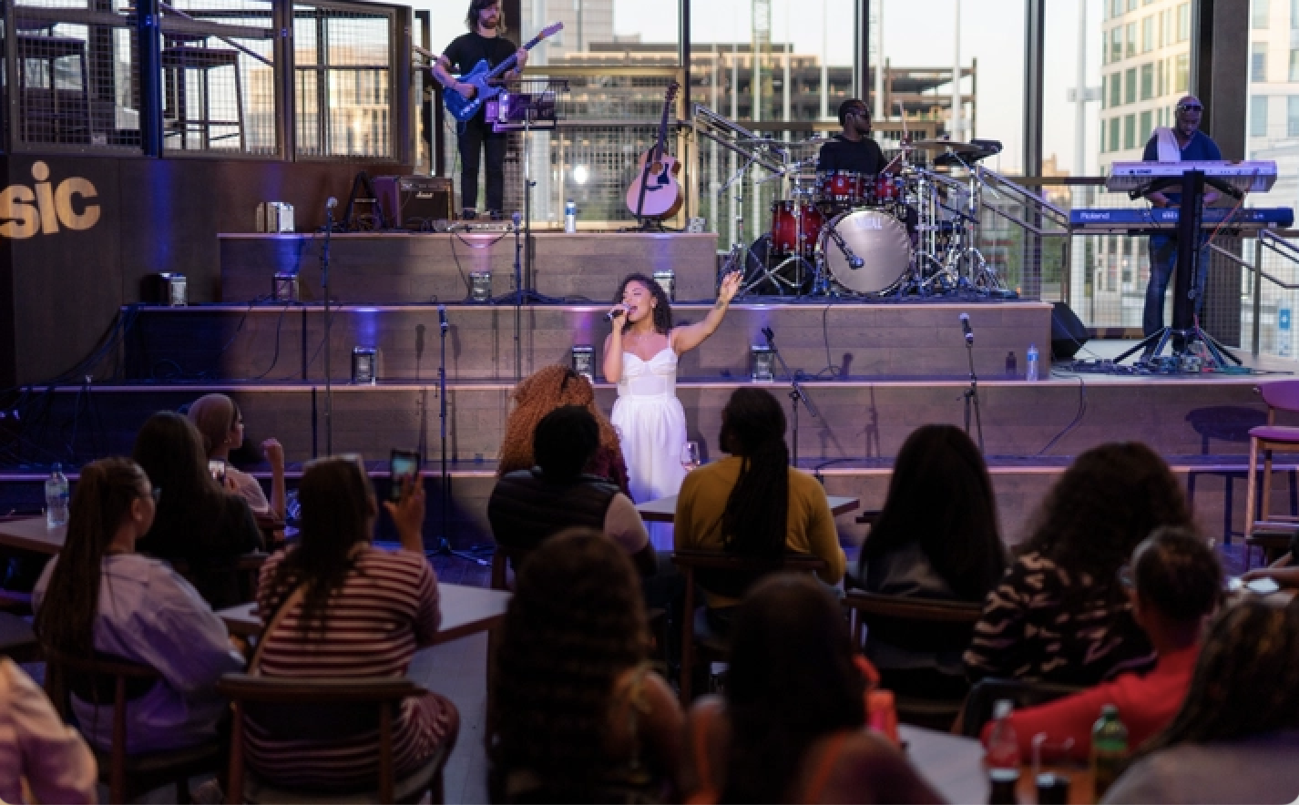

There will be amplified sound and some lighting changes in the Jennifer Blackwell Performance Space.

1. **Justham Family Room - You will enter the Justham Family Room from level 5a.**

This is wherethe workshops will happen.

Here is a picture of the Justham Family Room:

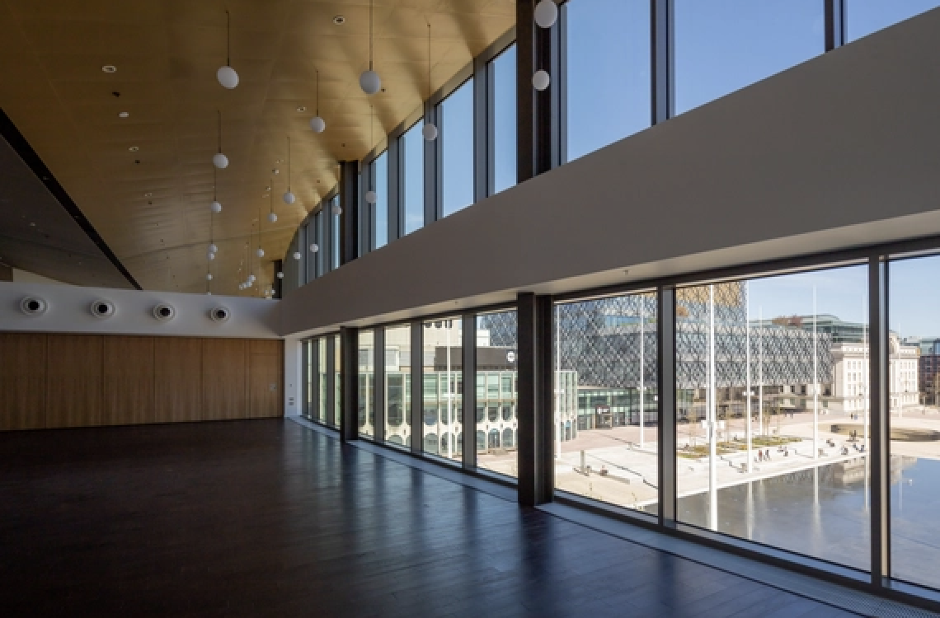

There will be some amplified sound and use of musical instruments in the Lantern Hall. There will be use of a screen and chairs in here for you to sit down.

**What can I do at Together for Music?**

You can see the programme for the day on the Music for Youth website.

In the programme you will find information about the **different performances and activities**, **when** and **where** they are taking place.

**Here is w**hat you can expect to happen on the day and some activities that you might want to take part in.

|  |  |  |
| --- | --- | --- |
| **Welcome Desk** | 9am-3pm, Ground Floor, Level 3 |  |
| **Musical Marketplace** | 9:00am-3.00pm, Foyer, Level 4 |  |
| **Performance 1** | 10am – 12pm Jennifer Blackwell Performance Space, Level 4 |  |
| **Workshop 1** | 11am-12pm, Justham Family Rooms, Level 5a |  |
| **Performance 2** | 1pm-3pm, Jennifer Blackwell Performance Space, Level 4 |  |
| **Workshop 2** | 1pm-2pm, Justham Family Rooms, Level 5a |  |
| **Trinity Talks** | 2.15pm –2.45pm, Justham Family Room, Level 5a |  |

**Wheelchair Users**



All the spaces used in Together for Music can be accessed by wheelchair users.

The floors at the main entrance from Centenary Square is flat and the door open automatically.

There are 2 lifts to take you to the other floors.

**Toilets**

Accessible toilet facilities are found on all levels and are signposted in the building.

There is a ‘Space to Change’ toilet located on Level 4.

**We are looking forward to welcoming you to Symphony Hall!**

When something is new, this might make us feel a little nervous or anxious… and that is ok.

We might also feel happy or excited… that is all OK too.

We will have ear plugs (for children over 12 years) available at the Welcome Desk, but you might want to bring your ear defenders.

If you need help on the day, ask one of our stewards or a member of staff at our Welcome Desk.

**If you have any questions about Together for Music, please contact Louise on:**

louise@mfy.org.uk

020 3948 3675