Together for Music
Schedule of the Day
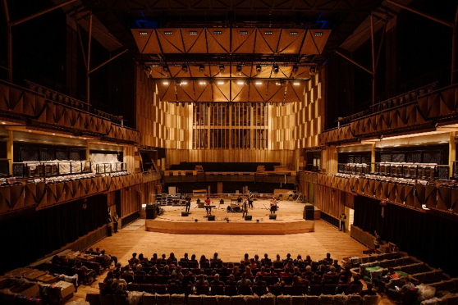 | Beacon Hall
Music
9.45am-11.45am
There will be young people performing music in Beacon Hall.

The musicians performing are:

- Alfreton Park School Orchestra
- Ashleigh and Lily
- Chapman Sum
- The Kings of Wessex Brass Ensemble

Talk
12pm-12.30pm

Trinity College London will talk to the audience about their music exams for everyone.
Music
12.45pm-2.30pm

More musicians will perform in Beacon Hall.
The musicians performing are:
- Blazing Taikos - Bidwell Brook School
- Rubik's Cube
- Westfield Arts College
- Ashleigh
- St Rose's School Orchestra
 | At 2.30pm, the event ends and everyone will leave Beacon Hall.

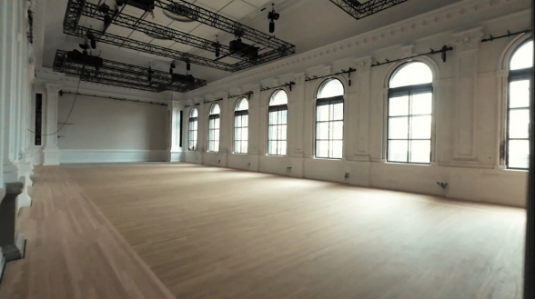 | Lantern Hall
 | There will be workshops you can join in Lantern Hall.
 | In the workshops you will play music with other young people.
 | There will be lots of instruments for you to play.
Workshop 1
10.45pm-11.45pm

The first workshop will be in the morning for one hour.

Workshop 2
12.45pm-1.45pm

The second workshop will be in the afternoon for one hour.

 | At 1.45pm, the workshops end and everyone will leave Lantern Hall.

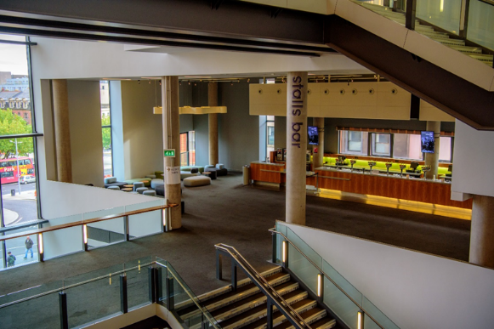 | Stalls Bar
 | There will be a Marketplace in the Stalls Bar area.
 | You can visit the Marketplace all day.
 | There might be lots of people in the Marketplace.
 | There will be some accessible instruments for you to try.
 | There people behind the stalls are from music organisations.
 | They would like to share information about their work.
Some of the organisations at the Marketplace are:
- Technology in Music Education
- Music For Youth
- Trinity College London
- Ev-Entz

 | The Marketplace will close at 3pm.

